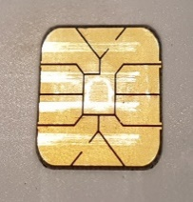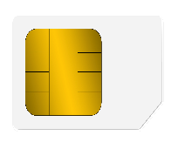

VALID 00/00

NAME SURNAME

1234

1234 4568 1234 4568

BANK

Debit card